

Cardiovascular Monitoring System Using IOMT and AI

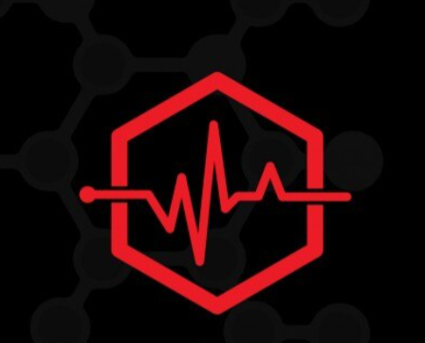

**By**

**Hala Abdeen Mostafa 202001392**

**Eman Gamal Hussien 202000135**

**Noor Allah Mohamed 202000119**

**Mina Mohab Sodek 202000557**

**Marwan Abd El Salam 20190086**

**Ahmed Khaled 201700264**

Under Supervision of

**Dr. Abdallah Ramadan fawzy**

A Project submitted to

**Canadian International College**

In Partial Fulfillment of the

Requirements for the Degree of Bachelor in

**Electronics and Communication Engineering**

CANADIAN INTERNATIONAL COLLEGE

CAIRO, EGYPT

2024-2025

### Abstract

The integration of the Internet of Medical Things (IOMT) and artificial intelligence (AI) has revolutionized modern healthcare, providing real-time monitoring, advanced analytics, and improved accessibility to critical health data. This graduation project focuses on the development of an IOMT-enabled wearable device designed to monitor patients' vital signs using advanced sensors. The collected data is transmitted to a cloud-based AI model, which processes and classifies the patient's condition.

The AI model leverages machine learning algorithms to detect patterns, anomalies, and potential health risks, delivering accurate classifications of the patient’s health status. The results are then sent back to a mobile application, where patients can access real-time updates about their health, including alerts and actionable recommendations.

This system ensures proactive healthcare management by enabling early detection of health issues and reducing the dependency on frequent hospital visits. It also empowers patients to take control of their health while streamlining the communication between patients and healthcare providers. The proposed solution demonstrates how IOMT and AI can work together to create a seamless, intelligent, and patient-centric healthcare system, paving the way for more efficient and accessible medical care.

**Acknowledgments**

First, we have to thank our project supervisor, Dr. Mahmoud Salah Hanafy. Without his assistance and dedicated involvement in every step throughout the process, we would never have accomplished what has been accomplished. We would like to Thank you very much for your support and understanding. Adding to that, our time at CIC has been highly productive, and working with the department's Doctors and TAs was an extraordinary experience. Also, we want to thank our families that without them we would not being here accomplished every step in our life.

Contents

Abstract 1

Chapter 1: () 6

1.6 9

2.1 16

2.2 16

2.3 17

2.4 18

2.5 18

2.6 19

2.7 20

2.8 20

2.9 21

2.10 21

2.11 21

Chapter 3: 22

3.3.1.1 28

3.3.1.2 28

3.3.1.3 28

3.3.1.4 29

3.3.2 29

3.3.3 29

3.5.1 39

3.5.2 40

Chapter 4: 48

4.1 48

4.2 55

4.2.1 55

4.2.3. 59

4.2.4 59

4.2.5 60

**List of Figures**

# Chapter 1: (System Integration )

**Chapter 2: (Ai)**

# Chapter 3: (APP)

# Chapter 4: (CODE & WHAT WE REACH AND FUTURE FEATURES $ CONCLUSION )

**References**